OTDE: 25G OTU Card
The 25G OTU service card launched by Sintai Communication Co., Ltd supports any four service access in the rate of 16~32G. Its main function is to finish the 2R re-generating and re-shaping of any 4-channel signals and then convert them 4 standard WDM wavelength signal, so that the MUX unit can multiplex the optical signals with different wavelengths and also achieve the reverse process. It’s applicable to the WDM transmission solution for eCPRI fronthaul transmission, 25G Ethernet, and 16G/32G FC service.
Product Diagram
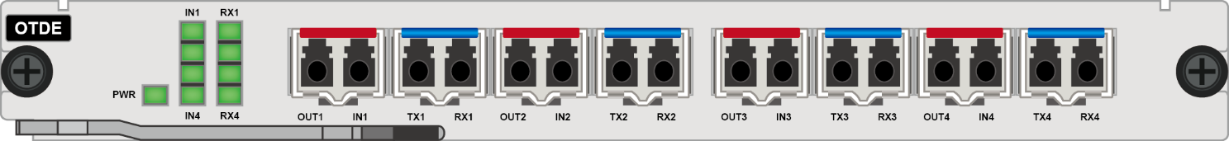
Functional Structure
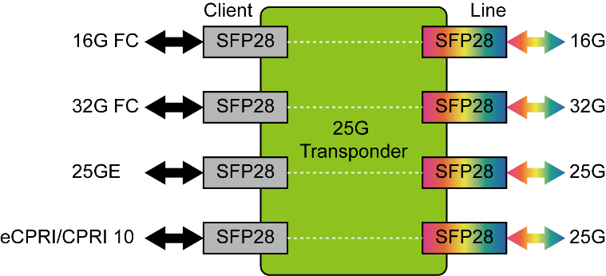
Product Specification
Item | Description
Interface | Client side interface: 4, based on SFP28 pluggable  Line side interface: 4, based on SFP28 pluggable
Line mode | It supports the transparent transmission of any type of services in the range of 16G ~ 32G, and can convert 4 service optical signals into 4 WDM standard wavelength optical signals
Relay mode | Support 16G ~ 32G wavelength electric relay
Access service type | - 25GE  - 16G FC (compatible with 32G)  - eCPRI、CPRI 10
Self-adaption | 16~32G rate adaptive, configuration free
WDM technology | - Support CWDM: 18 channels  - Support DWDM: C band 50GHz 80 channels
Occupied slot number | Occupy 1 slot, applicable to the whole OTNS 8600 series platform
Network management | - Supports real-time monitoring of port working state, including transmitting optical power, receiving optical power, temperature, etc.  - Support ALS function of optical port
Max power consumption | 16W (including the optical modules)
MTBF | ＞100000 hours

